 | MATHEMATICS:SPECIALIST  SEMESTER 1 2016  REVISION ASSIGNMENT VALIDATION  Calculator Free

Question 1 (6 marks)
OABC is a trapezium with . M lies on the diagonal OB so that  and N lies on the diagonal CA so that . Let 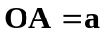 and 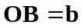.

By determining a vector for MN, or otherwise, prove that ABNM is a parallelogram.

Question 2 (8 marks)
Given 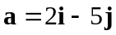 and 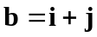, determine

(a) 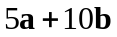. (1 mark)

(b) 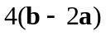. (1 mark)

(c) 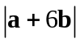. (2 marks)

(d) a unit vector in the same direction as 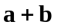. (2 marks)

(e) the scalar projection of b onto . (2 marks)

MATHEMATICS:SPECIALIST
SEMESTER 1 2017

REVISION ASSIGNMENT VALIDATION
Calculator Assumed

Question 3 (9 marks)
Points O, P, Q and R have position vectors 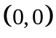, 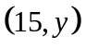, 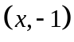 and 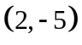.

(a) Determine the value of y if 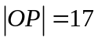. (2 marks)

(b) Determine the value of x if  . (3 marks)

(c) Determine the values of x and y if R lies on the line between P and Q such that 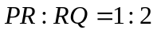. (4 marks)

Question 4 (8 marks)
Fifteen children at a summer camp are to be divided into two groups of nine and six.

(a) Determine the number of different groupings. (2 marks)

(b) Determine how many groupings are possible if the two youngest children must be in the same group. (3 marks)

(c) If ten of the fifteen were girls, in how many of the different groupings do both groups contain more girls than boys? (3 marks)

